Ideation Phase
Brainstorm & Idea Prioritization Template

Date | 11 October 2025
Team ID | SWUID20250177148
Project Name | SB Works
Maximum Marks | 4 Marks

Brainstorm & Idea Prioritization Template:
Fresh graduates and skilled freelancers struggle to find genuine, high-quality projects, while clients find it difficult to connect with verified and reliable talent. The challenge is to create a trustworthy and efficient platform that streamlines project workflows, ensures transparency, and fosters secure collaboration between both parties without overwhelming them.
Step-1: Team Gathering, Collaboration and Select the Problem Statement

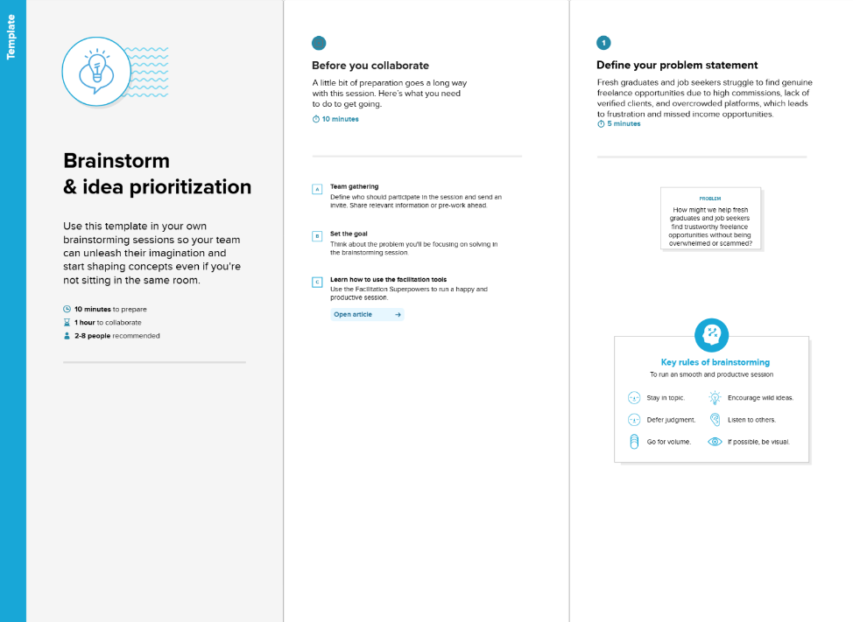

Step-2: Brainstorm, Idea Listing and Grouping
Based on the problem statement, the team brainstormed the following core features and solutions for the SB Works platform:
- Verified Freelancer Profiles: Allow clients to assess past work and review freelancer profiles to select the best candidate.
- Secure Admin Oversight: Implement a dedicated admin team to ensure the integrity, security, and quality of freelancers and transactions on the platform.
- Skill-based Project Matching: Enable clients to post diverse projects and allow freelancers to bid based on their specific expertise.
- Client-Freelancer Review System: Foster a collaborative environment where clients can review submitted work and provide constructive feedback.
- Integrated Communication System: A seamless, in-platform chat system to facilitate smooth communication and collaboration between clients and freelancers.
- Streamlined Project Submission: A straightforward process for freelancers to submit completed work directly through the platform.

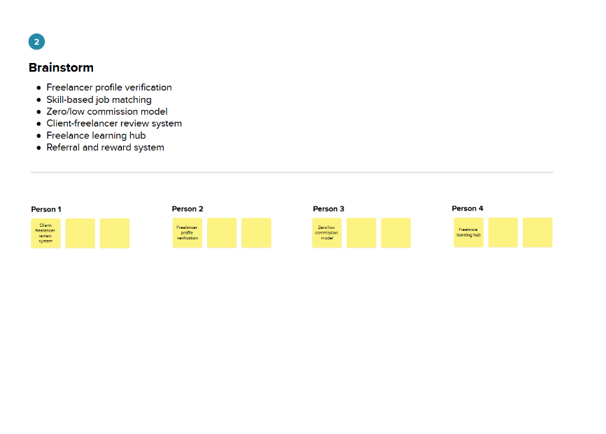
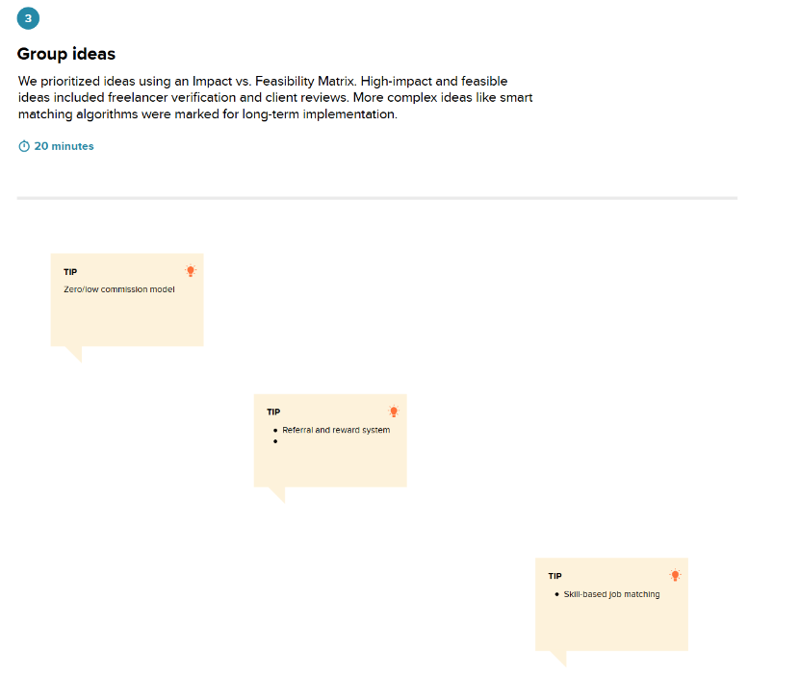

Step-3: Idea Prioritization
We grouped the brainstormed ideas using an Impact vs. Feasibility approach to identify core functionalities.
- Trust and Security (High Impact):
  - This group includes ideas critical for building user confidence.
  - Features: Verified Freelancer Profiles, Secure Admin Oversight, Client-Freelancer Review System.
- Workflow and Collaboration (High Impact):
  - This group focuses on making the process from hiring to project completion as smooth as possible.
  - Features: Integrated Communication System, Streamlined Project Submission.

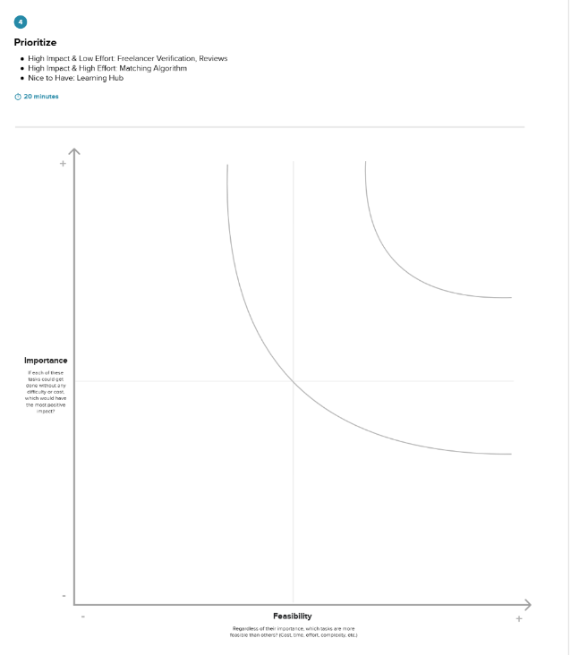

The following prioritization is based on an Importance vs. Feasibility matrix, ensuring that the most critical and achievable features are developed first.
- High Importance & High Feasibility (Core Features):
  - These are the essential features for the platform to function and build trust.
  - Ideas:
    - Verified Freelancer Profiles
    - Client-Freelancer Review System
    - Streamlined Project Submission
- High Importance & Moderate Feasibility (Complex but Necessary Features):
  - These features are crucial but require more development effort.
  - Ideas:
    - Secure Admin Oversight
    - Integrated Communication System (Chat)
- Nice to Have (Future Enhancements):
  - These features would add value but are not critical for the initial launch.
  - Ideas:
    - Real-time notifications about industry trends

